------Merge Sort-------

-----Dividing Part------

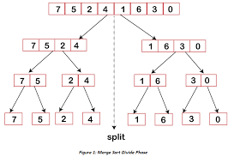

MergeSort(A, p, r) //Sort A[p…r] by divided & conquer

İf p < r

Then q 🡨 (p+r)/2

MergeSort (A, p, q)

MergeSort(A, q+1, r)

Merge(A, p, q, r)//merges A[p….q] with A[q+1..r]

------Merging Part-----

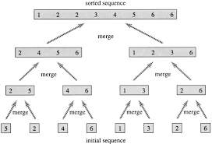

procedure merge( var a as array, var b as array )

var c as array

( while a and b have elements )

if ( a[0] > b[0] )

add b[0] to the end of c

remove b[0] from b

else add a[0] to the end of c

remove a[0] from a

end if

end while

while ( a has elements )

add a[0] to the end of c

remove a[0] from a

end while

while ( b has elements )

add b[0] to the end of c

remove b[0] from b

end while

return c end procedure